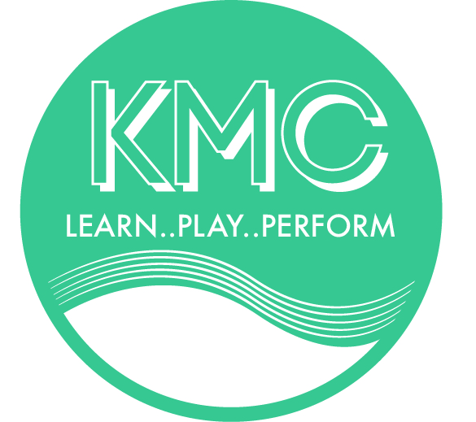
KMC Trust
P.O. Box 2003
Raumati Beach
kmc.org.nz

3 February 2020
KAPITI MUSIC CENTRE UPDATE
Hi everyone.
You are receiving this newsletter because your child attended lessons with us last year. Due to our imminent move into the Kapiti Performing Arts Centre I wanted pass on some important dates and events which may be of interest to you. You will not receive any further newsletters from KMC unless you are enrolled with us this year.

ENROLMENTS FOR 2020 are open. Please complete a form from the website. Please indicate choices of times you can attend lessons.
KMC ENROLMENT DAYS
SATURDAY 8 FEBRUARY 10.30am – 12.00pm
MONDAY 10 FEBRUARY 5.30pm – 7.00pm
In
KAPITI COLLEGE MUSIC DEPARTMENT (M Block)
Please let your friends know
Yes we are teaching out of the new Performing Arts Centre but until the opening on 22 February we are unable to move in hence having enrolments in the old music rooms.
KAPITI PERFORMING ARTS CENTRE PUBLIC OPEN DAY
SATURDAY 22 FEBRUARY 9.30AM – 3.00PM
everyone welcome
Due to a very busy first week at Kapiti College the start for Term 1 is being postponed by 1 week to begin on
MONDAY 2 MARCH – KMC lessons begin
2020 TERM DATES:
Term 1 – Begins 1 March Finishes 9 April (6 weeks)
Term 2 – Begins 4 May Finishes 2 July (9 weeks)
Term 3 – Begins 20 July Finishes 24 September (10 weeks)
Term 4 – Begins 12 October Finisher 23 November (6 weeks)

